HCI Project-2

The purpose of the Bespoke font is to provide a dynamic and visually striking typeface designed specifically for high-speed environments like racing games.

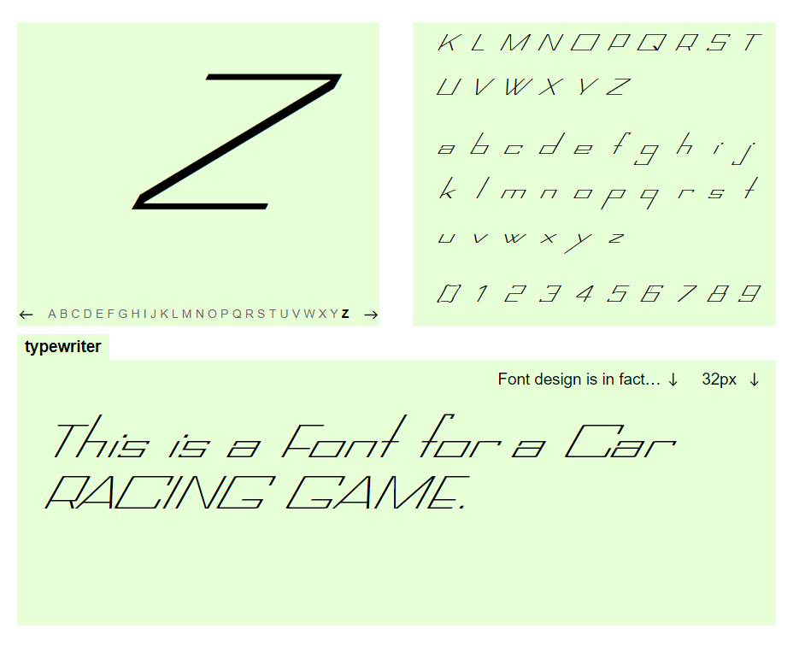

The word ***bespoke*** has evolved from a verb meaning 'to speak for something', to its contemporary usage as an adjective. Originally, the adjective *bespoke* described tailor-made suits and shoes. Later, it described anything commissioned to a particular specification (altered or tailored to the customs, tastes, or usage of an individual purchaser). In contemporary usage, *bespoke* has become a general marketing and branding concept implying exclusivity and limited runs.

The font aims to enhance the gaming experience by embodying the key elements of speed, motion, and precision. It is crafted to ensure maximum readability, even during rapid in-game animations where characters assemble from different corners, while maintaining a modern and sleek aesthetic that resonates with the fast-paced, competitive nature of car racing.

Here’s the detailed design decisions and use cases for your Bespoke font in a table format:

|  |  |  |  |  |  |  |  |  |  |  |  |  |  |  |  |  |  |  |  |  |  |  |  |  |  |  |  |  |  |  |  |  |  |  |  |  |  |  |  |  |  |  |  |  |  |  |  |  |  |  |  |  |  |  |  |  |  |  |  |  |  |  |  |  |  |  |  |  |  |
| --- | --- | --- | --- | --- | --- | --- | --- | --- | --- | --- | --- | --- | --- | --- | --- | --- | --- | --- | --- | --- | --- | --- | --- | --- | --- | --- | --- | --- | --- | --- | --- | --- | --- | --- | --- | --- | --- | --- | --- | --- | --- | --- | --- | --- | --- | --- | --- | --- | --- | --- | --- | --- | --- | --- | --- | --- | --- | --- | --- | --- | --- | --- | --- | --- | --- | --- | --- | --- | --- |
| |  |  |  |  |  |  |  |  |  |  |  |  |  |  |  |  |  |  |  |  |  |  |  |  |  |  |  |  |  |  |  |  |  |  |  |  |  |  |  |  |  |  |  |  |  |  |  |  |  |  |  |  |  |  |  |  |  |  |  |  |  |  |  |  |  |  |  |  |  | | --- | --- | --- | --- | --- | --- | --- | --- | --- | --- | --- | --- | --- | --- | --- | --- | --- | --- | --- | --- | --- | --- | --- | --- | --- | --- | --- | --- | --- | --- | --- | --- | --- | --- | --- | --- | --- | --- | --- | --- | --- | --- | --- | --- | --- | --- | --- | --- | --- | --- | --- | --- | --- | --- | --- | --- | --- | --- | --- | --- | --- | --- | --- | --- | --- | --- | --- | --- | --- | | | Aspect | Design Decision | Justification | Use Case | | --- | --- | --- | --- | | **Unit Width (2)** | Wide unit width for spacious characters | Ensures readability, especially when characters are animated or moving | Quick readability in racing game where text forms from different corners | | **Pen Width (0.41)** | Thin strokes for a sleek, modern appearance | Reflects speed and agility, making the font lightweight and aerodynamic | Suitable for fast-paced, high-motion environments like car racing | | **Cap Height (0.93)** | Bold capital letters with a balanced height | Enhances legibility for capitalized words and maintains proportional harmony with lowercase letters | Ideal for in-game headers or important text displays | | **Bar Height (0.27)** | Minimal horizontal interruptions | Ensures a fluid and continuous look | Keeps text flowing smoothly in dynamic settings | | **Ascender Height (1.25)** | Taller ascenders for increased clarity | Provides better legibility, especially for letters like "l", "h", and "b" | Useful for short in-game messages and quick instructions | | **Descender Height (0.66)** | Moderate descenders for compact design | Keeps the font from appearing too stretched out while adding elegance | Efficient for racing game menus or quick pop-up text elements | | **X-height (0.5)** | Balanced lowercase height in proportion to capital letters | Ensures readability while keeping lowercase letters distinct from capital | Readable even in smaller UI elements of the game, such as labels | | **Horizontal Increase (0.51)** | Slight expansion in width | Gives a dynamic, expanded feel, mimicking acceleration | Adds a sense of movement to the characters, ideal for race-related text animation | | **Vertical Increase (0.47)** | Proportional vertical expansion | Enhances visual dynamism without overwhelming the user | Perfect for in-game banners or fast-moving HUD (Heads-Up Display) | | **Contrast (1.58)** | High contrast between thick and thin strokes | Enhances visual appeal and makes letters more distinct | Effective for branding, logos, or scoreboards where contrast draws attention | | **Superness (0.98)** | Well-balanced proportions across all characters | Ensures readability and consistency without excessive exaggeration | Useful in all types of in-game text where balance is critical for fast comprehension | | **Slanting (0.57)** | Moderate slant for a sense of speed | Conveys motion and agility, resonating with the fast-paced nature of racing | Suitable for animated text, or where an italicized, agile feel is required | | **Aperture (0.13)** | Small aperture keeps letters compact without being too tight | Ensures clarity while maintaining the compactness necessary for quick recognition | Ideal for in-game instructions or text where space is limited but clarity is essential | | **Corner (1.0)** | Sharp corners give the font an edgy, aggressive feel | Reflects the fast decisions and sharp turns in racing | Works well in leaderboard displays or racing-related branding | | **Overshoot (0.1)** | Minimal overshoot for visual correction | Aligns curved characters optically with others to maintain uniformity | Useful for animated text where alignment of characters is critical for readability | | **Taper (0.5)** | Slight tapering for a streamlined, aerodynamic look | Adds a sense of speed and sleekness to the design | Perfect for fast-paced game menus, instructions. | | |

This font is not just a tool for communication, but also a design element that reinforces the high-octane, fast-paced nature of racing.

**Use Cases:**

1. **In-Game Display:**

Dynamic Text Assembly: Since the characters in your game come from different corners to form sentences, the font needs to have a clear and legible design even during animation. The chosen proportions and spacing ensure the letters can be easily read as they move.

Speed and Motion Representation: The slanting and slight tapering of the letters give a sense of speed, making them suitable for racing game contexts where the visual needs to evoke fast-paced action.

1. **Race Track Signage and HUD (Heads-Up Display):**

High Contrast and Sharp Corners: The font's high contrast between thick and thin strokes, combined with its sharp corners, makes it ideal for in-game signage, lap counters, or time trackers where quick, at-a-glance information is needed.

Clear Numeric Representation: The clarity and balance of the numbers (0-9) ensure that critical race data such as speed, lap number, and time are easily readable, even in motion.

1. **In-Game Dialogue or Instructions:**

Balanced Proportions for Readability: The moderate x-height and well-proportioned ascenders and descenders make it comfortable to read short bursts of dialogue or instructions, which are essential in fast-paced racing games where the user’s attention is constantly divided.

1. **Branding and Promotional Material:**

Sleek and Modern Aesthetic: The thin pen width, combined with the slight slant and taper, makes the font suitable for promotional materials such as posters, game menus, or loading screens, where a modern and sophisticated appearance is required.

Racing Theme Alignment: The overall design evokes a sense of speed, precision, and modernity, making it a good fit for the branding of the game, whether in the title screen, logos, or in-game advertisements.

A racing game format like ASPHALT 8 AIRBONE

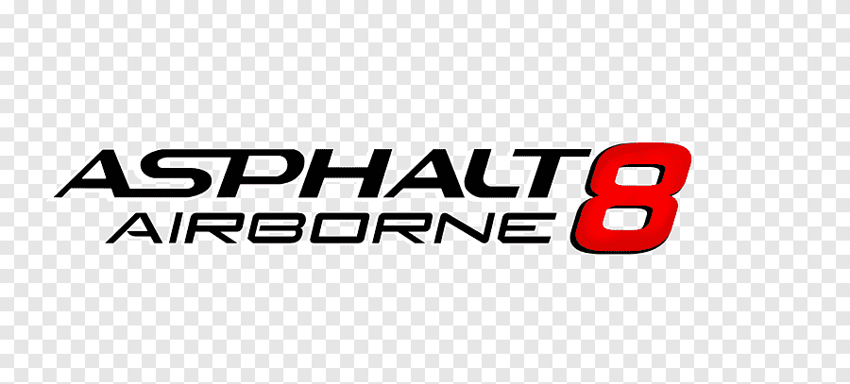

**Comparison of Bespoke Font with Asphalt 8: Airborne:**

|  |
| --- |
| COMPARSON |
| | ***Aspect*** | **Bespoke Font** | **Asphalt 8: Airborne Font** | | --- | --- | --- | | ***Theme*** | Dynamic, sleek design for high-speed racing environments | Bold, edgy font to emphasize speed and excitement | | ***Legibility*** | Wide characters with good spacing for quick readability | Clear, large text, especially for in-game prompts and timers | | ***Motion Representation*** | Slight slant and taper to suggest speed and movement | Often straight, thick strokes for power and impact | | ***User Experience*** | Focuses on smooth readability during dynamic assembly of text | Prioritizes high contrast and size for easy recognition during gameplay | | ***Design Purpose*** | Designed to reflect speed, precision, and agility in text | Reinforces the fast-paced, adrenaline-filled nature of the game | | ***Visual Appeal*** | Modern, sleek with optical corrections for sharper corners | Uses bold lines and sharp edges to make the text pop | |

**Bespoke** focuses more on sleek, aerodynamic aesthetics and motion, while **Asphalt 8** uses bolder, more powerful fonts to emphasize the thrilling, high-energy nature of the game. Both cater to fast readability but with different design philosophies.